**NAME: ZAHRA DUA**

**SAPID: 64880**

**Programming fundamental**

**Lab tasks:**

**lAB MANUAL:**

**Question 1:**

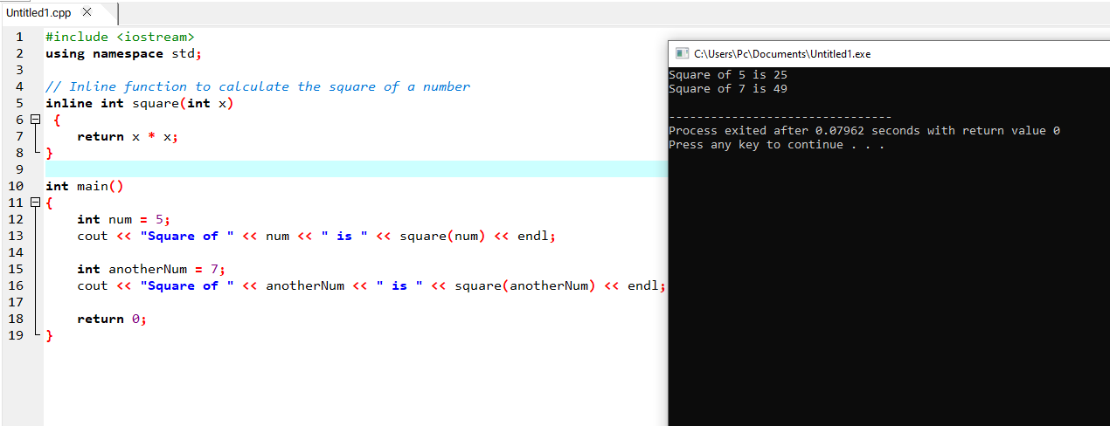

**Question 2:** 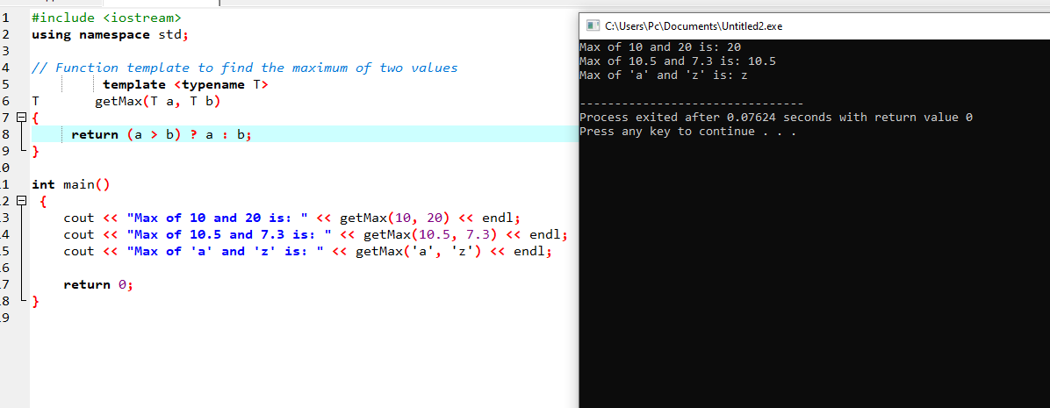

**Question 3:** 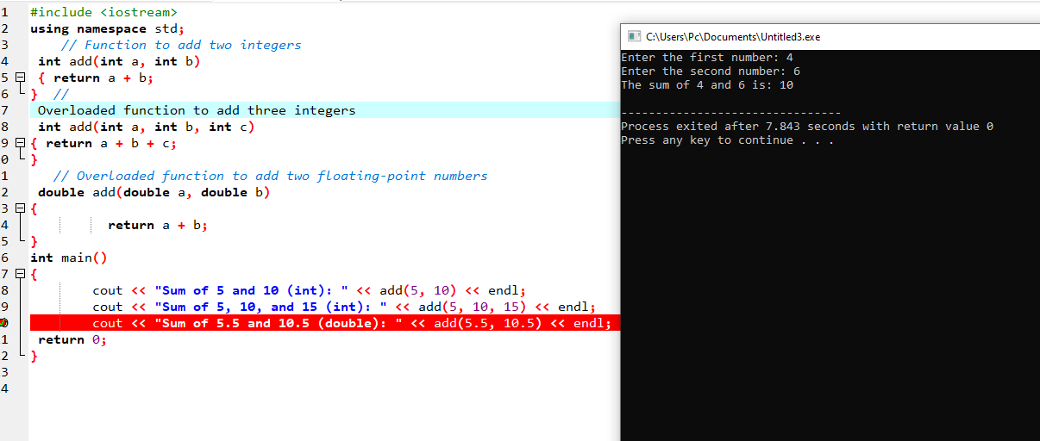

**Lab tasks:**

**Question 1:**

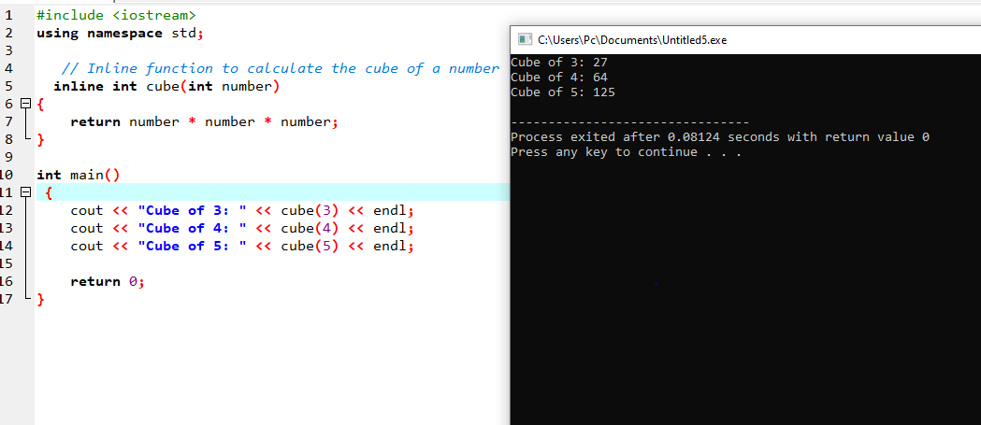

**Question 2:**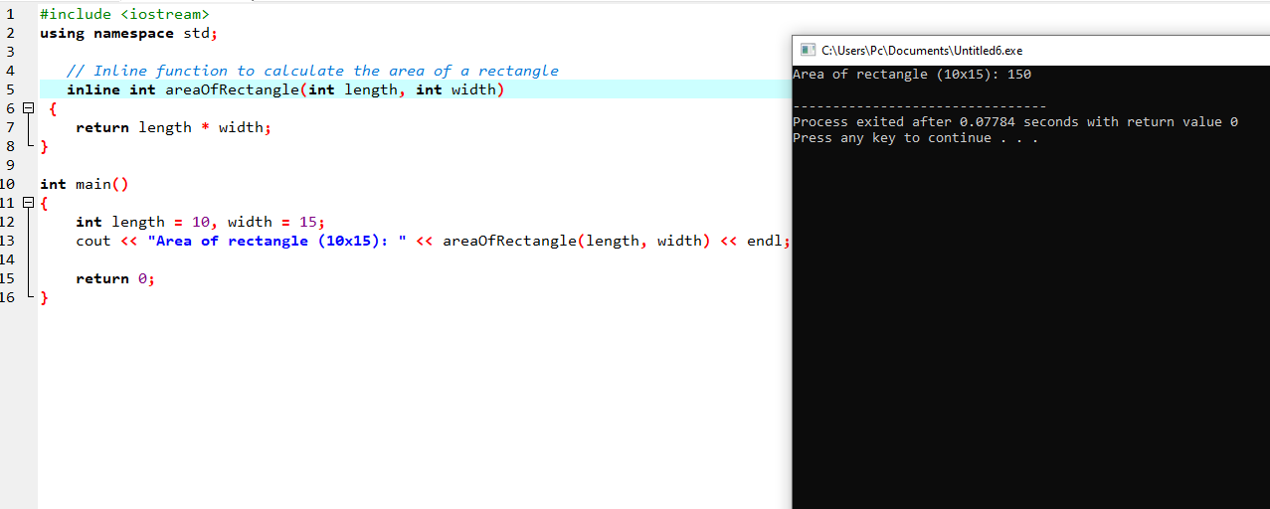

**Question 3:**

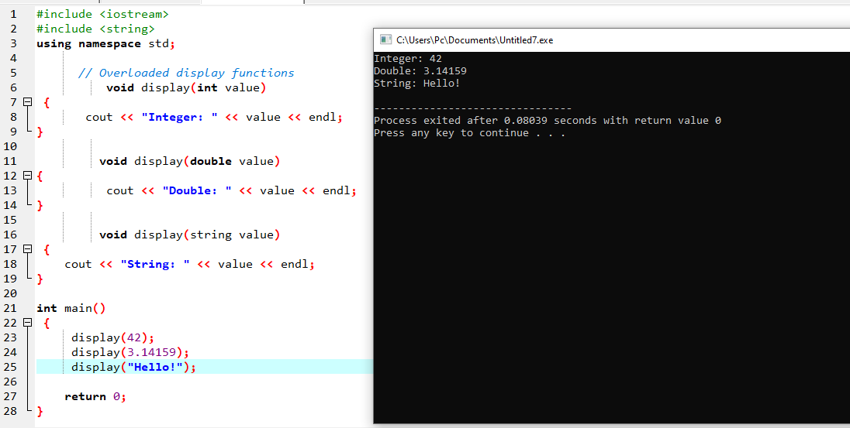

**Question 4:** 